**PLSQL_Exercises**

**Exercise 1: Control Structures:**

Step 1 - First we will create two table “Customers” and “Loans” in the database -

* **Table Customers:**

CREATE TABLE Customers (

CustomerID NUMBER PRIMARY KEY,

Name VARCHAR2(50),

Age NUMBER,

InterestRate NUMBER(5,2),

Balance NUMBER(10,2),

IsVIP VARCHAR2(5)

);

* **Table Loans:**

CREATE TABLE Loans (

LoanID NUMBER PRIMARY KEY,

CustomerID NUMBER,

DueDate DATE

);

**Step 2** – Now we will add sample values to our tables for testing the scenarios.

* **Table Customers:**

INSERT INTO Customers VALUES (1, 'John', 65, 10.5, 12000, 'FALSE');

INSERT INTO Customers VALUES (2, 'Jane', 45, 9.2, 8000, 'FALSE');

INSERT INTO Customers VALUES (3, 'Mark', 70, 11.0, 15000, 'FALSE');

**select * from customers;**

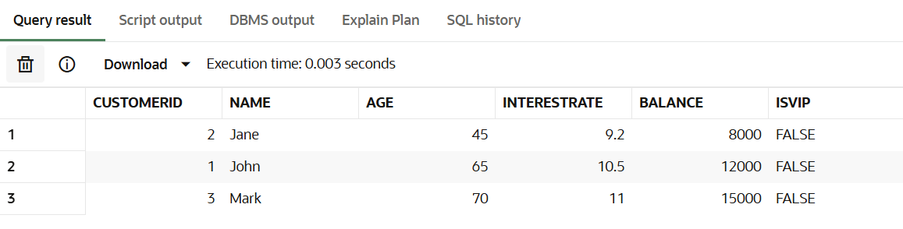

* **Table Loans:**

INSERT INTO Loans VALUES (101, 1, SYSDATE + 10);

INSERT INTO Loans VALUES (102, 2, SYSDATE + 40);

INSERT INTO Loans VALUES (103, 3, SYSDATE + 25);

**select * from loans;**

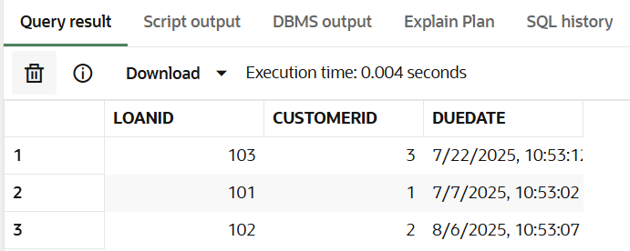

**Step 3** – Given Scenarios.

* **Scenario 1** - The bank wants to apply a discount to loan interest rates for customers above 60 years old.

BEGIN

FOR cust_rec IN (SELECT CustomerID, InterestRate

FROM Customers

WHERE Age > 60)

LOOP

UPDATE Customers

SET InterestRate = InterestRate - 1

WHERE CustomerID = cust_rec.CustomerID;

END LOOP;

COMMIT;

END;

**Output:** Select * from Customers;

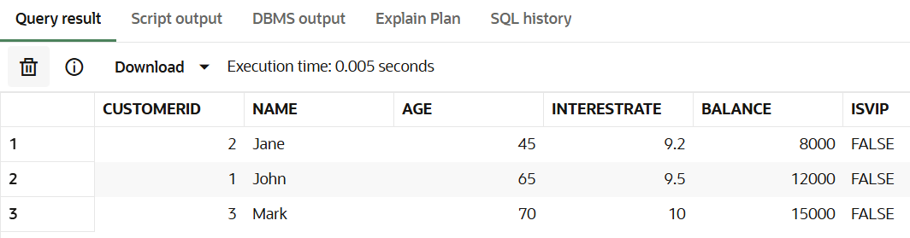

* **Scenario 2** - A customer can be promoted to VIP status based on their balance.

BEGIN

FOR cust_rec IN (SELECT CustomerID

FROM Customers

WHERE Balance > 10000)

LOOP

UPDATE Customers

SET IsVIP = 'TRUE'

WHERE CustomerID = cust_rec.CustomerID;

END LOOP;

COMMIT;

END;

**Output:** Select * from Customers;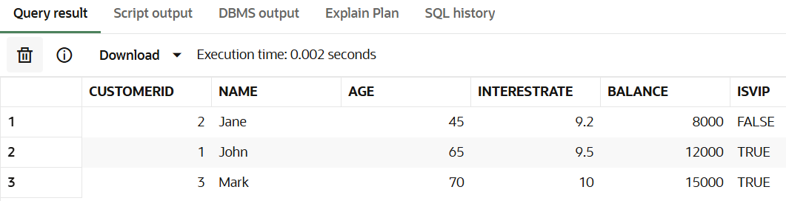

* **Scenario 3** - The bank wants to send reminders to customers whose loans are due within the next 30 days.

BEGIN

FOR loan_rec IN (

SELECT LoanID, CustomerID, DueDate

FROM Loans

WHERE DueDate BETWEEN SYSDATE AND SYSDATE + 30

)

LOOP

DBMS_OUTPUT.PUT_LINE('Reminder: Loan ID ' || loan_rec.LoanID ||

' for Customer ID ' || loan_rec.CustomerID ||

' is due on ' || TO_CHAR(loan_rec.DueDate, 'DD-MON-YYYY'));

END LOOP;

END;

**Output:** Select * from Loans; 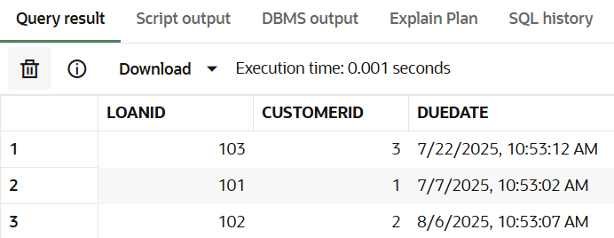

**Exercise 3: Stored Procedures:**

**Step 1** – First we will create the tables – Savings Account, Employees, General Accounts.

* **Table SavingsAccounts**

CREATE TABLE SavingsAccounts (

AccountID NUMBER PRIMARY KEY,

CustomerID NUMBER,

Balance NUMBER(10,2)

);

* **Table Employees**

CREATE TABLE Employees (

EmployeeID NUMBER PRIMARY KEY,

Name VARCHAR2(50),

Department VARCHAR2(50),

Salary NUMBER(10,2)

);

* **Table Accounts (for General Accounts)**

CREATE TABLE Accounts (

AccountID NUMBER PRIMARY KEY,

CustomerID NUMBER,

Balance NUMBER(10,2)

);

**Step 2** – Adding values to the tables for testing the scenarios.

* **Table SavingsAccounts**

INSERT INTO SavingsAccounts (AccountID, CustomerID, Balance) VALUES (1, 101, 5000);

INSERT INTO SavingsAccounts (AccountID, CustomerID, Balance) VALUES (2, 102, 10000);

INSERT INTO SavingsAccounts (AccountID, CustomerID, Balance) VALUES (3, 103, 7500);

**Output:** Select * from SavingsAccounts;

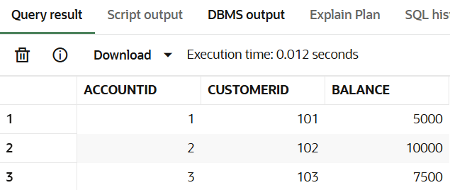

* **Table Employees**

INSERT INTO Employees (EmployeeID, Name, Department, Salary) VALUES (1, 'Alice', 'Sales', 50000);

INSERT INTO Employees (EmployeeID, Name, Department, Salary) VALUES (2, 'Bob', 'Sales', 55000);

INSERT INTO Employees (EmployeeID, Name, Department, Salary) VALUES (3, 'Charlie', 'IT', 60000);

INSERT INTO Employees (EmployeeID, Name, Department, Salary) VALUES (4, 'Diana', 'IT', 65000);

**Output:** Select * from Employees;

* **Table Accounts(for General Accounts)**

INSERT INTO Accounts (AccountID, CustomerID, Balance) VALUES (1, 201, 8000);

INSERT INTO Accounts (AccountID, CustomerID, Balance) VALUES (2, 202, 3000);

INSERT INTO Accounts (AccountID, CustomerID, Balance) VALUES (3, 203, 12000);

Output: Select * from Accounts;

**Step 3** – Given Scenarios.

* **Scenario 1 –** The bank needs to process monthly interest for all savings accounts.

CREATE OR REPLACE PROCEDURE ProcessMonthlyInterest IS

BEGIN

FOR acc IN (SELECT AccountID, Balance FROM SavingsAccounts) LOOP

UPDATE SavingsAccounts

SET Balance = Balance + (acc.Balance * 0.01)

WHERE AccountID = acc.AccountID;

END LOOP;

COMMIT;

END;

To Execute : BEGIN

ProcessMonthlyInterest;

END;

**Output:** Select * from SavingsAccounts;

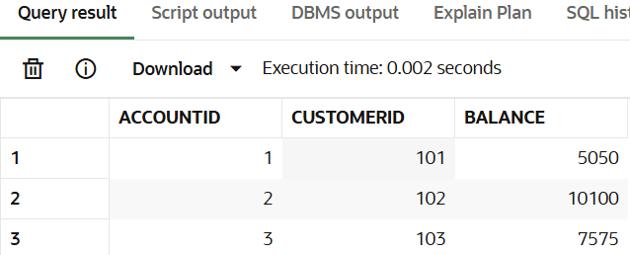

* **Scenario 2 –** The bank wants to implement a bonus scheme for employees based on their performance.

CREATE OR REPLACE PROCEDURE UpdateEmployeeBonus (

p_department IN VARCHAR2,

p_bonus_percent IN NUMBER

) IS

BEGIN

UPDATE Employees

SET Salary = Salary + (Salary * p_bonus_percent / 100)

WHERE Department = p_department;

COMMIT;

END;

To Execute : BEGIN

UpdateEmployeeBonus('Sales', 10);

END;

**Output:** Select * from Employees;

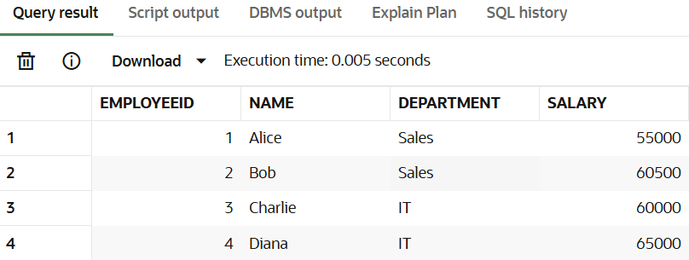

* **Scenario 3 –** Customers should be able to transfer funds between their accounts.

CREATE OR REPLACE PROCEDURE TransferFunds (

p_from_account IN NUMBER,

p_to_account IN NUMBER,

p_amount IN NUMBER

) IS

v_balance NUMBER;

BEGIN

SELECT Balance INTO v_balance

FROM Accounts

WHERE AccountID = p_from_account;

IF v_balance >= p_amount THEN

-- Deduct from source

UPDATE Accounts

SET Balance = Balance - p_amount

WHERE AccountID = p_from_account;

UPDATE Accounts

SET Balance = Balance + p_amount

WHERE AccountID = p_to_account;

COMMIT;

ELSE

RAISE_APPLICATION_ERROR(-20001, 'Insufficient balance in source account.');

END IF;

END;

To execute: BEGIN

TransferFunds(1, 2, 100);

END;

**Output:** Select * from Accounts;

